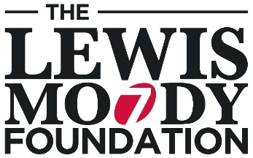
The Lewis Moody Foundation
Donation Form
Please give generously. We can’t do this without you.

Donation

I wish to donate £25 £100 £250 Other amount £

Your Details

Title |  | Mr Mrs Ms Miss Other – please specify:
First name |  |  |  | Surname
Address
Town |  |  |  | Postcode
Daytime Tel |  |  |  | Mobile
Email
Payment Details
I enclose a cheque made payable to The Lewis Moody Foundation for
Please charge my credit/debit card for
Name on card
Card number |  |  | / / / |  | Security number (3 digits on back)
Valid from date |  |  | / / |  | Issue no
Expiry date |  |  | / /
Signature
Print Name |  |  |  | Date |  |  | / /
Gift Aid Declaration
Would you like The Brain Tumour Charity to reclaim the tax on your donation on behalf of The Lewis Moody Foundation?

☐ I confirm that I’m a UK tax payer and want to Gift Aid my donation and any other donations I have made in the past four years or make in the future to The Brain Tumour Charity on behalf of The Lewis Moody Foundation. I’m aware that The Charity will reclaim 25p of tax on every £1 that I give and understand that I must pay more Income tax and/or Capital Gains Tax for that tax year than the amount of Gift Aid claimed on all my donations, I know it’s my responsibility to pay any difference. If my circumstances change, I will notify The Brain Tumour Charity on behalf of The Lewis Moody Foundation.

We will record your details on our secure database, so we can provide you with the best possible service every time you contact us and allow us to keep you up-to-date on the work your donation is enabling us to achieve. Your details will be kept securely and only shared with suppliers and partners who enable us to deliver our work, for example, distribution of our newsletter. We never sell or swap your details with any third parties. If you would prefer us not to use your details in this way, you can email donations@thebraintumourcharity.org, call us on 01252 749043 or write to us at The Brain Tumour Charity, Hartshead House, 61-65 Victoria Road, Farnborough GU14 7PA.

We’re tackling illness, fulfilling dreams

