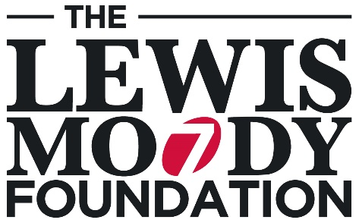
Gift Aid certificate
  - Thank you for choosing to make a donation to
The Lewis Moody Foundation in support of our work.

Tackling illness, fulfilling dreams

thelewismoodyfoundation.org
  - Your donation is worth so much more to us when it is Gift
Aided. Please complete this form and return it to us at:
Hartshead House, 61-65 Victoria Road, Farnborough GU14 7PA.
Brain tumours are the biggest cancer killer of children and adults under 40,
yet they receive less than 2% of funding on cancer research and survival
times have improved little over the last 40 years.
The Lewis Moody Foundation, inspired by Joss Rowley-Stark, funds ground
breaking research to improve the diagnosis and treatment of brain tumours and
gives families a day out of the ordinary to lift spirits and create special memories.
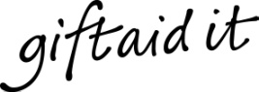 |  |  |  | Please Gift Aid your donation so we can claim Gift Aid tax  relief of 25p on every pound you give at no extra cost to you
  - My details (this must be your home address)
Name:
Address:
Postcode:
Tel: |  |  |  |  | Email:
We will record your details on our secure database, so we can provide you with the best possible service every time you contact us and allow us to keep you up-to-date on the work your donation is enabling us to achieve. Your details will be kept securely and only shared with suppliers and partners who enable us to deliver our work, for example, distribution of our newsletter. We never sell or swap your details with any third parties. If you would prefer us not to use your details in this way, you can email info@thelewismoodyfoundation.org, call us on 01252 749990 or write to us at The Lewis Moody Foundation, Hartshead House, 61-65 Victoria Road, Farnborough GU14 7PA.

  - Gift Aid declaration
I confirm that I’m a UK tax payer and want to Gift Aid my donation and any other donations I have made in the past four years or make in the future to The Brain Tumour Charity on behalf of The Lewis Moody Foundation. I’m aware that The Charity will reclaim 25p of tax on every £1 that I give and understand that I must pay more Income tax and/or Capital Gains Tax for that tax year than the amount of Gift Aid claimed on all my donations, I know it’s my responsibility to pay any difference. If my circumstances change, I will notify The Brain Tumour Charity.
☐ I agree that The Brain Tumour Charity, on behalf of The Lewis Moody Foundation, can claim Gift Aid on all donations I have paid in the last four years and all donations I make from the date of this declaration until I notify you otherwise.
- Signature: |  |  |  |  |  |  | - Date:
  - Please notify us if you:
- Want to cancel your Gift Aid declaration
- Change your name or home address
- No longer pay sufficient tax on your income and/or capital gains.
If you pay Income Tax at the higher or additional rate and want to receive the additional tax relief due to you, you must include all your Gift Aid donations on your Self Assessment tax return or ask HM Revenue and Customs to adjust your tax code.
If you have any queries please get in touch: info@thelewismoodyfoundation.org / 01252 749990

